Introduction to the atmosphere

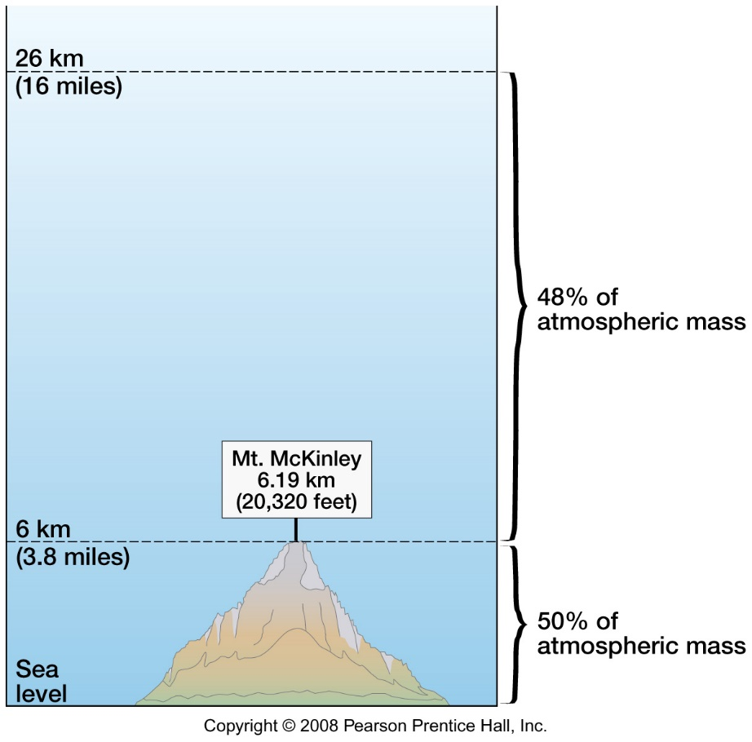

50% of the mass of the atmosphere is within 3.8 mi. or 6 km of sea level. Very little (2%) is higher than 16 mi. or 26 km. The density of the atmosphere decreases with altitude.

The ***permanent gases*** of the atmosphere are mostly Nitrogen (~78%) and Oxygen (~21%). If the remaining ~1%, the dominant element is Neon (.93%) which is an inert gas.

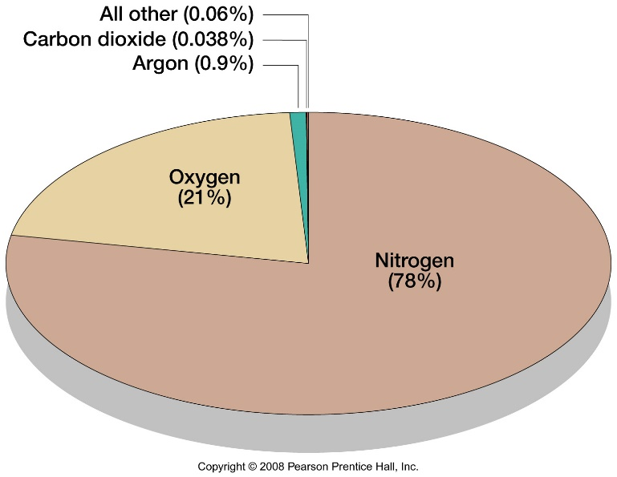

We strongly associate the very important element oxygen with the atmosphere. However, the rocky crust of earth is more dominantly composed of oxygen (more than 90% by volume) with the next most abundant element being silicon.

The ***variable gases*** of the atmosphere include water vapor (an important one for us as we look at clouds, precipitation, etc.), Carbon dioxide, measured in parts per million (now exceeding 400 ppm), Ozone (both in the stratosphere and near the earth’s surface), and Methane (from decomposition, natural gas emissions, and other sources).

The structure of the atmosphere can be examined with this figure and highlights of the various layers, starting nearer the earth’s surface, where we will focus our attention this term.

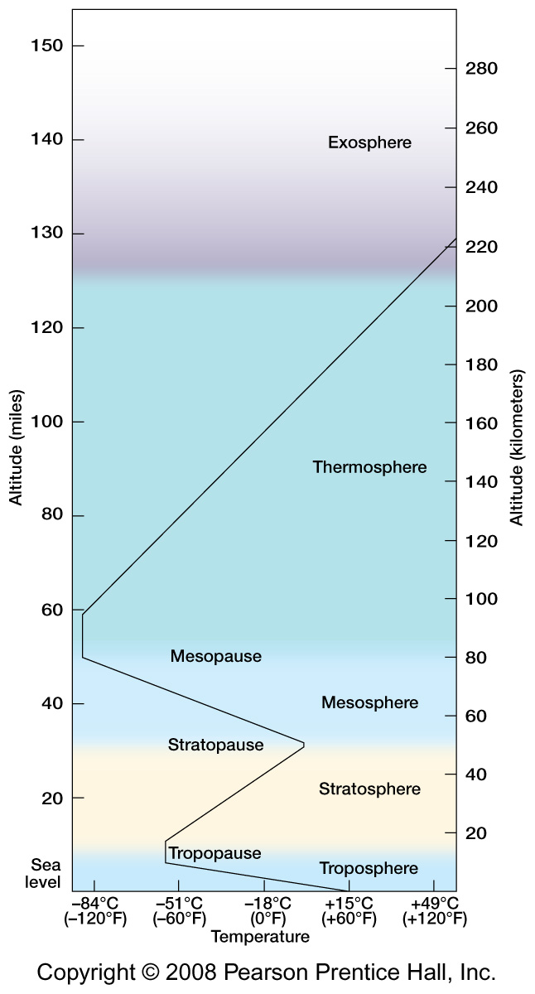

The ***Troposphere*** is derived from a term meaning to turn (circulating), referring to the mixing particularly vertically in the lower atmosphere. The Troposphere is 0-11 mi. (0-18 km) thick at the equator and 0-5 mi. (0-8 km) thick at the poles. Note that temperature decreases upward in the troposphere from an average of about 59 degrees F or 15 degrees C at sea level to about -71 degrees F or -57 degrees C at the Tropopause. The earth’s surface is warmed by incoming solar radiation and this heats up the atmosphere. The temperature decays or drops upward with the lower density of the air. About 80% of the mass of the atmosphere is in the Troposphere and this is where we will concentrate our studies.

The ***Stratosphere*** translates as a cover, stratified or layered, like a lid, being more stagnant with low mixing. The Stratosphere extends from about 11-30 mi. or 18-48 km above sea level. The top of Mt. Everest does not reach the Stratosphere. The upper Stratosphere is also the ***Ozonosphere*** which heats up as it absorbs ultraviolet rays from the sun, which means that the Stratosphere gets warmer upward.

The ***Mesosphere*** (which means “middle”) is between about 30-50 mi. or 48-80 km and its temperature decreases upward. The Mesosphere, Stratosphere and Troposphere constitute the ***Homosphere*** which means they are more homogenous or uniform in composition than the layers above.

The ***Thermosphere*** (which means “heat”) occurs at about 50-125 mi. or 80-200 km and is another layer that warms upward as UV rays are absorbed splitting and heating molecules of Hydrogen, Helium, Oxygen, and Nitrogen. This is also the ***Heterosphere***, which is heterogeneous, where gases are separated by their atomic weight.

The ***Exosphere*** is above 125 mi. or 200 km and is external or blending into space, with some traces of the atmosphere.

The ***Ionosphere*** is in the Thermosphere where excitation of atoms, or charged molecules produce the Aurora Borealis (Northern Lights).

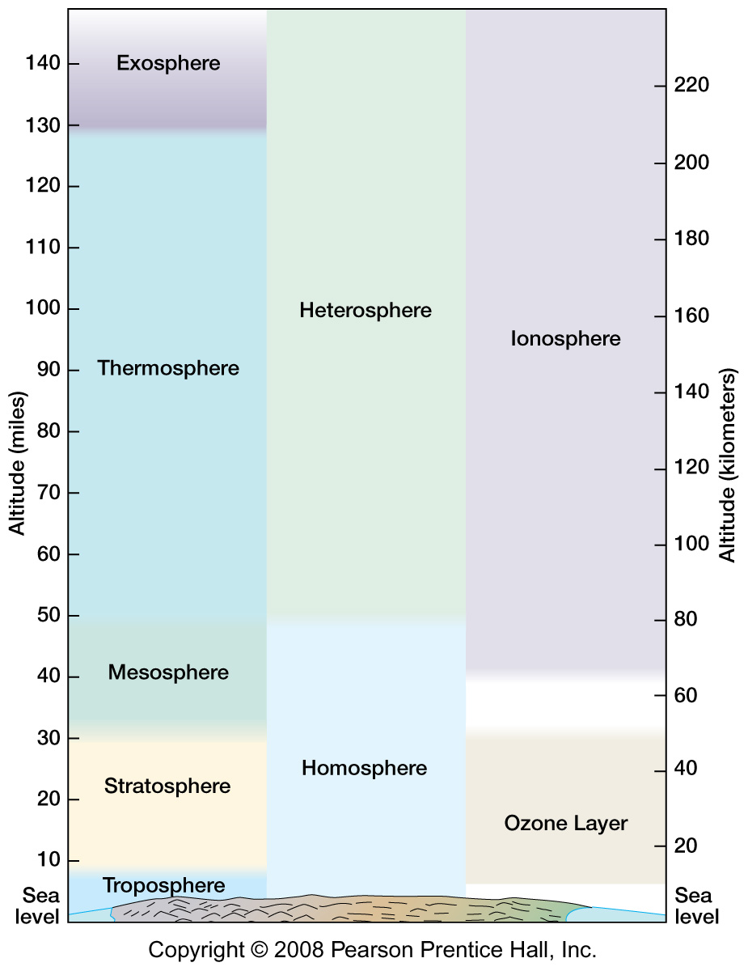

The ozone layer (Ozonosphere) describes a population of large oxygen molecules, with three oxygen atoms bonded together. Most oxygen molecules are a pair of oxygen atoms. In the Stratosphere UV-B and UV-C radiation breaks apart pairs of oxygen, freeing the single atoms to bond with a pair and form a trio of oxygen atoms (ozone). The larger oxygen molecules are then broken back apart (again by UV) and absorb energy in the process.

***Ozone depletion*** in the stratosphere allows more energetic ultraviolet rays (UV-B especially) to increasingly penetrate the atmosphere. Impacts on the human population include higher incidences of skin cancers, especially in Antarctica and areas fringing the southern polar area, like New Zealand, southern Australia, and the southern tip of South America (see image of ozone hole in 2006, below).

The balance of ozone formation and decay in the stratosphere is altered when the elements Chlorine and Bromine are introduced. Each extra Chlorine atom in the stratosphere can dissociate (separate) more than 100,000 ozone molecules. Chlorine compounds made by humans such as chlorofluorocarbons (CFCs) have been widely used in air conditioning systems and bromine compounds used for pesticides in agriculture. Currently the ozone levels appear to be recovering somewhat as humans phase out the use of some of these chemicals.

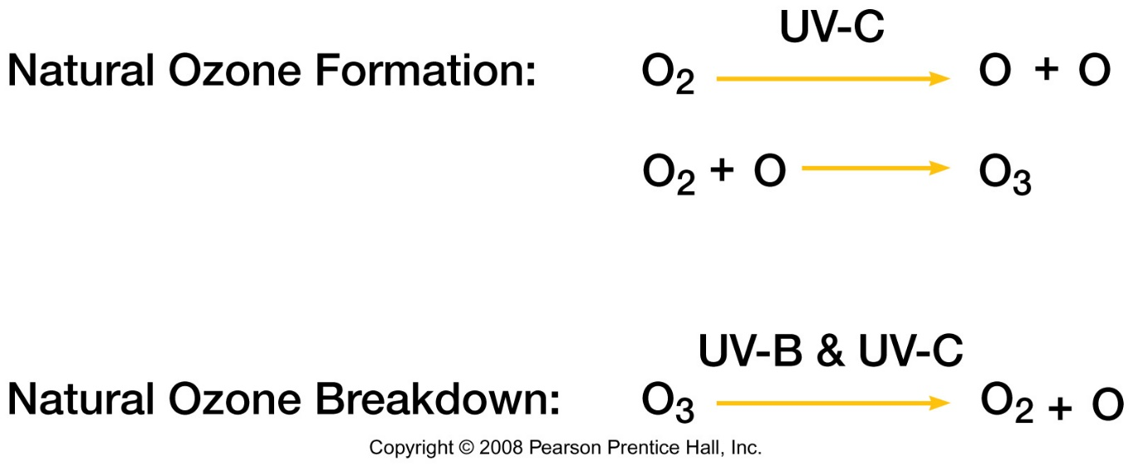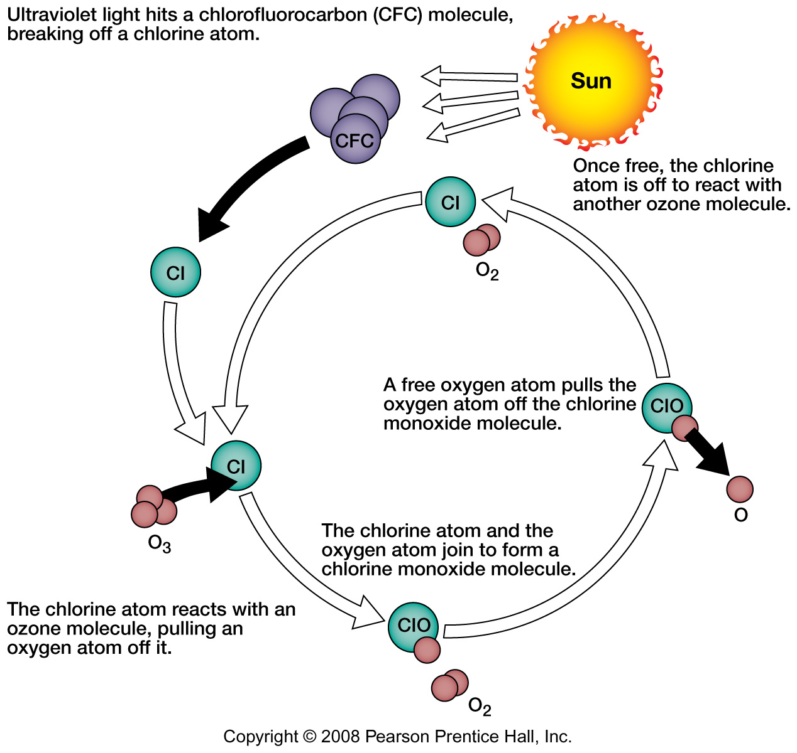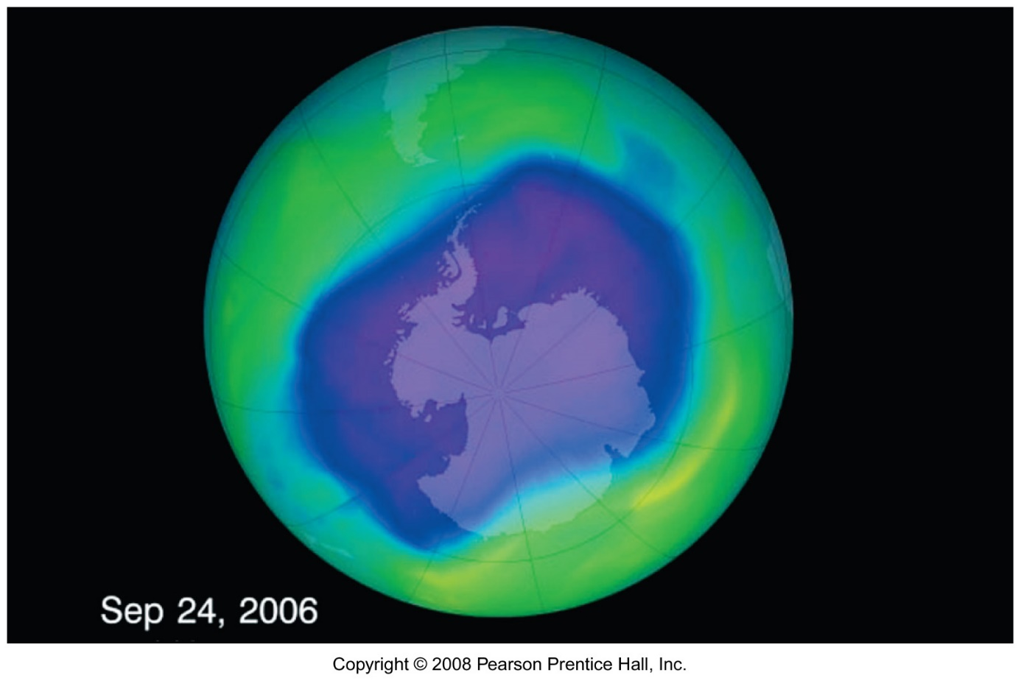

Why is ozone depletion concentrated over the Antarctic and to a lesser extent the Arctic regions? Cold polar air is very dense and sits in a big blob over the south pole especially during the Antarctic winter. The cold air doesn’t move much. With summer hemisphere spring coming sunlight returns and exacerbates the loss of ozone. Later there some mixing this part of the atmosphere and the “ozone hole” heals somewhat seasonally.

***Air pollution*** includes particles like dust, smoke, and emissions from engines and industry. Major pollutants include:

Carbon monoxide (CO) is derived from incomplete burning of fuels,

Nitrogen compounds, e.g. NO, are sourced especially from auto engines,

Sulfur compounds like hydrogen sulfide are emitted from volcanoes and burning of higher sulfur coal and petroleum, especially in power plants,

And Photochemical smog is produced from reactions with sunlight. Note that low level ozone is produced by photochemical reactions near the ground and is a human health problem. This is especially acute during hot summer days in cities with a lot of air pollution.

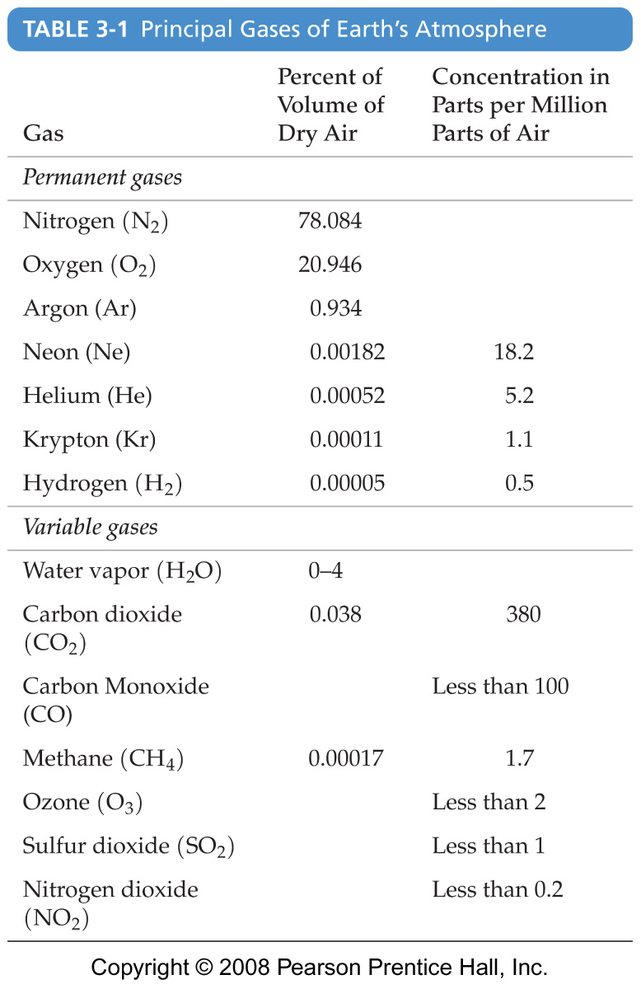

***Weather and climate***

We look extensively at weather and climate and some major controls include:

***Latitude,*** in which the sun angle (or angle of incidence) and day lengths through the year affect the climate.

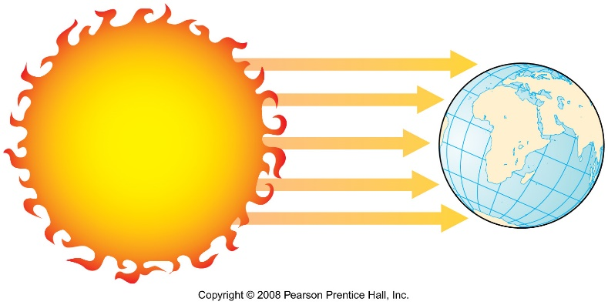

***Land and water,*** and its distribution. Water as a substance stores a considerable amount of energy for its volume (known as its specific heat). Water can also absorb energy over a great depth than land surfaces, especially if it is more transparent. Water is mobile and can circulate and cools by evaporation. Water regulates temperature, heating and cooling more slowly than land.

***Ocean circulation*** cycles heated water away from the tropics with the ocean currents. 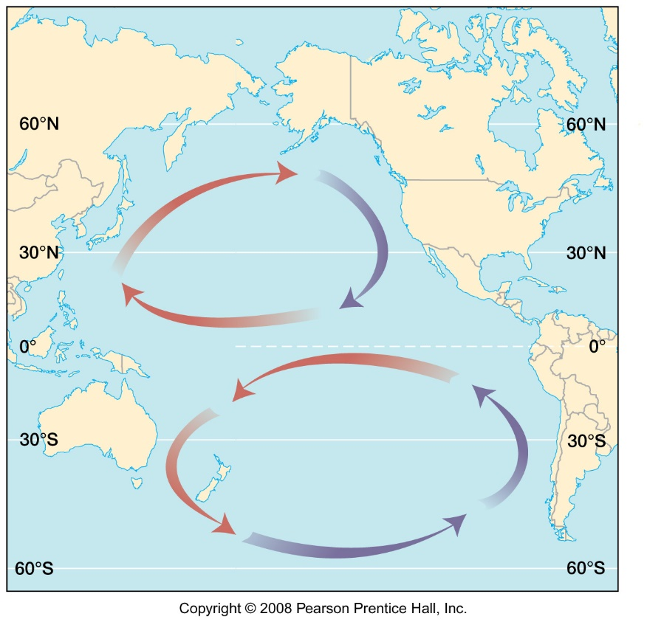

Ocean and air circulation are driven by the Corolis effect and the rotation of the earth. 